Customer Experience Workflow

**Solution 4: Suggest a Response for a Work Item**

**June 20, 2023**

This document catalogs the Microsoft Tech for Social Impact AI Solutions Project, delivered in collaboration with threshold.world. It includes detailed description of expected customer experience for accessing, downloading, installing, deploying, and utilizing the AI Solution.

Contents

Installation and Configuration 3

Prerequisites 3

Set up an OpenAI API Key 3

Manual Solution Installation 5

Utilizing the AI Solution 12

Grant Requests Summary​ 12

# Installation and Configuration

## Prerequisites

It's important to review the following prerequisites before you deploy or install the solution.

* Dynamics 365 Sales Enterprise must be installed
* Microsoft Cloud for Nonprofit – Fundraising and Engagement. (see [Deploy or upgrade Fundraising and Engagement](https://learn.microsoft.com/en-us/dynamics365/industry/nonprofit/fundraising-engagement-deploy-installer))
* Common Data Model for Nonprofits Sample Apps (solutions can be found [here](https://github.com/microsoft/Industry-Accelerator-Nonprofit/releases))
* You must be a Microsoft Power Platform admin, Dynamics 365 admin, or a tenant admin to deploy solutions

## Set up an OpenAI API Key

Before getting an API key, you need to go to [OpenAI’s official platform website](https://platform.openai.com/). If you haven’t already, create an account following the simple steps on the website. Once you have created an account or have logged in with an existing account, you’ll see your name and your profile icon at the top-right corner of OpenAI’s platform homepage.

To get an API key,

1. Log in to your OpenAI account.
2. Click on your name in the upper right corner and select **View API keys** from the drop-down menu**.**

1. To get a new secret key, click the **Create new secret key** button near the center of the page. 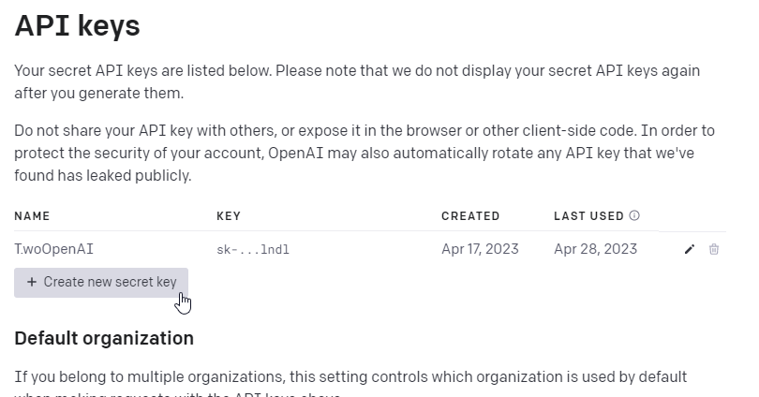
2. On the create new secret key dialog, enter a name for your API key and click **Create secret key**

1. A new secret key will be generated. Make sure to save the secret key somewhere safe as soon as possible. Once the dialog closes, you won’t be able to view the secret key again.

## Manual Solution Installation

1. Before installing the solution, make sure you have the solution file in your machine. (Filename: **TSI_OpenAI_IncidentResponse_1_0_0_0.zip**)
2. Go to the [Maker Portal](https://make.powerapps.com/)
3. On the top right, select the environment where you want to install the solution.

1. On the left navigation pane, click **Solutions**

1. Click **Import solution**

1. Browse to the location of the solution file downloaded at step 1 and click **Next**

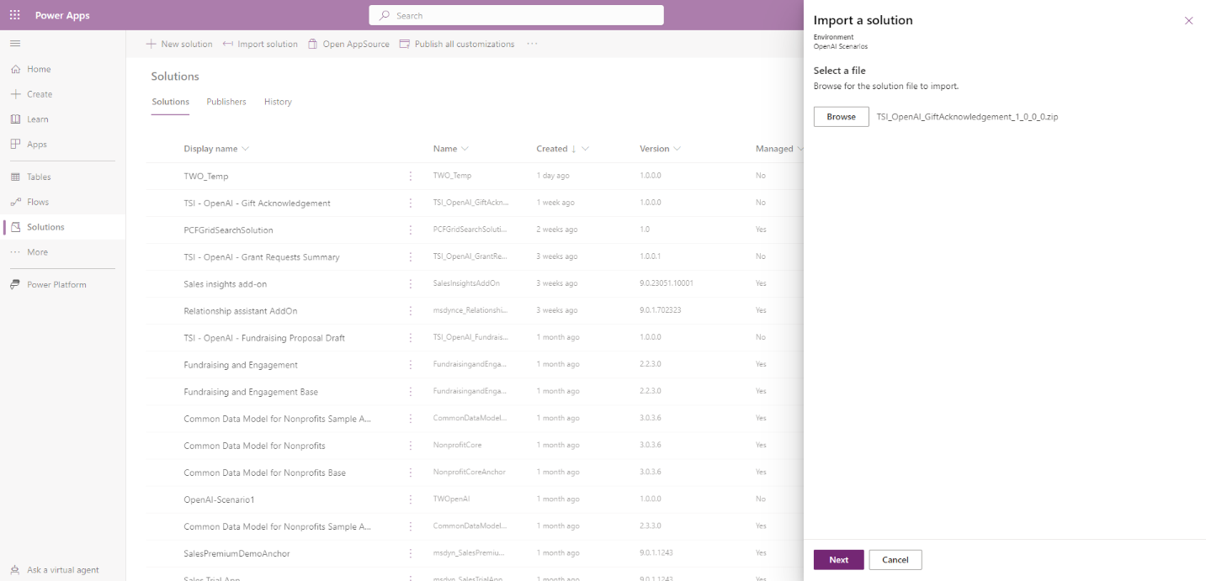

1. On the confirmation window click **Next**

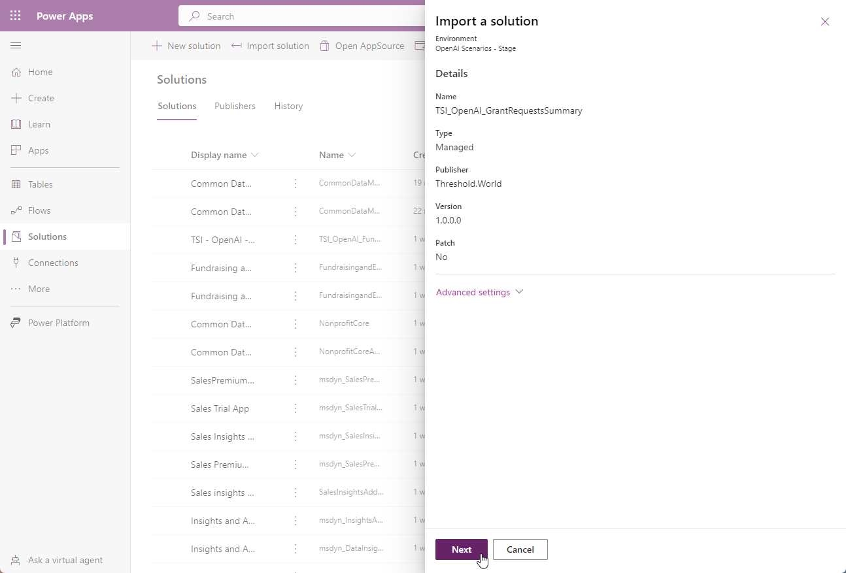

1. The import process will ask you to reestablish a connection. A connection is needed for the Power Automate Flow that is part of the solution. This connection provides access to the org-based database on Microsoft Dataverse in current environment. If a connection already exists, you can select it from the dropdown and you can jump to step 12. In case there are no connections, Click the dropdown next to the connection reference and click **New Connection.**

1. A new window will open to create the connection. On the dialog, click **Create**

1. Pick an account or log in with an account that has access to the current Dataverse Environment

1. After creating the connection, go back to the previous window and click **Refresh** on the dialog shown. That will refresh the connections dropdown.

1. Select the newly created connection from the dropdown next to the connection reference and click **Next.**

1. Wait until the import process completes.

# Utilizing the AI Solution

## Generate Incident Response

MKTG MESSAGE

The following guidelines will show how to use the predeveloped solution:

1. Go to your organization’s Dynamics 365 CRM portal (e.g.

<https://organizationid.crm.dynamics.com>).

1. From the list of apps, select the **Case Management** model-driven app.

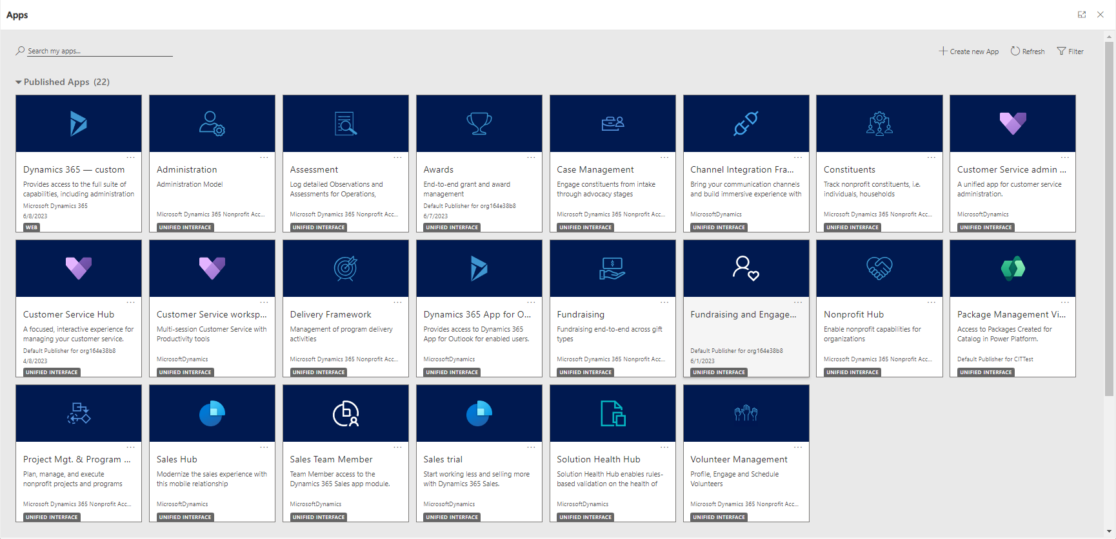

1. From the navigation pane, select **Work Item Actions**. Then, select any **Incident**.

1. From the detail view for any Incident, select **Generate Response** to open the Incident Response generator. A side panel dialog opens, which shows 3 sections:
   1. Information about the selected Incident.
   2. Additional Guidance and Generation of Incident Response – this section allows the user to add more guidance or context before sending the data to OpenAI.
   3. Generated Incident Response – this section shows the AI generated response. Also allows the user to edit that response before creating the Work Item Action.

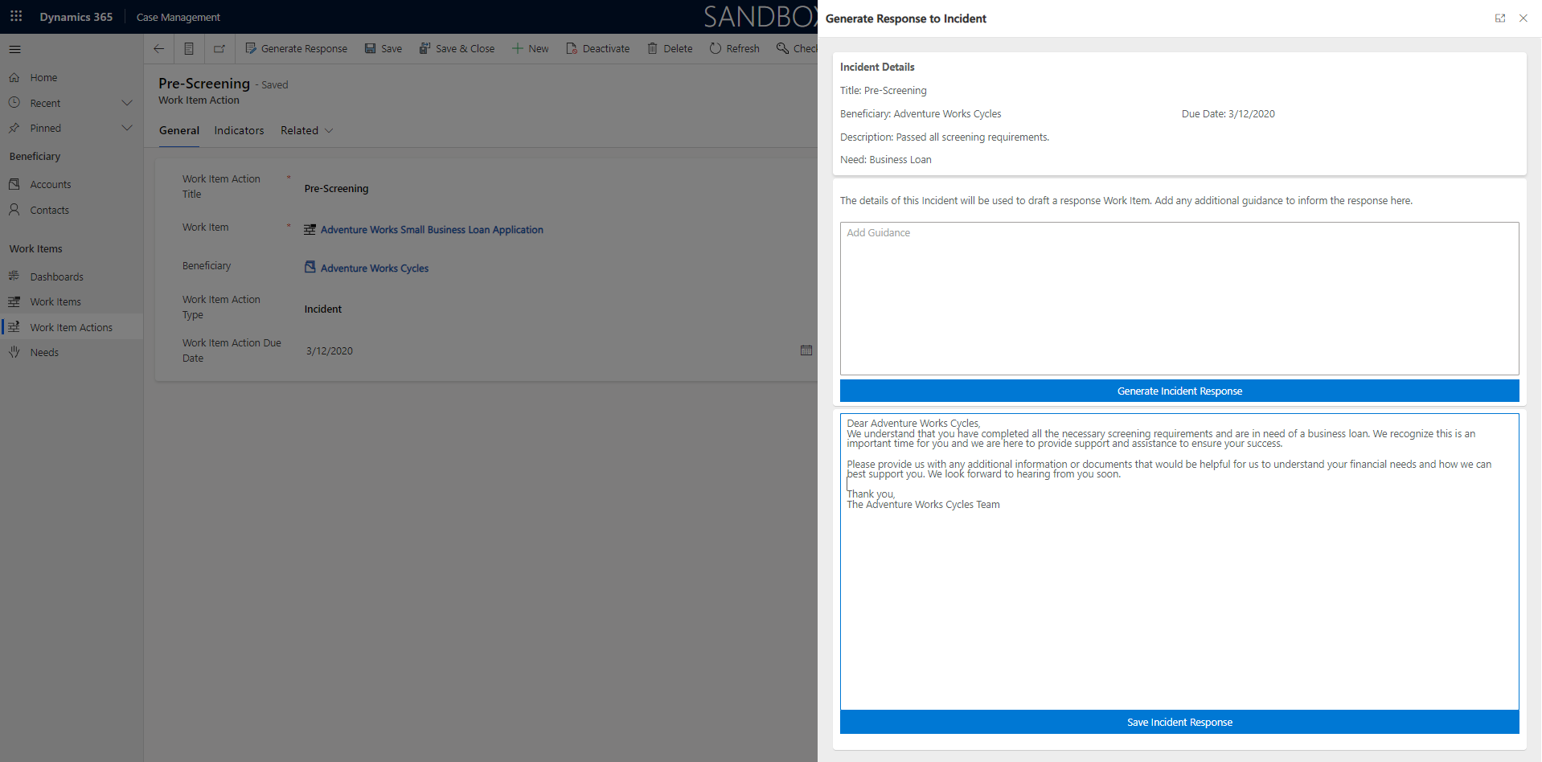

1. Once the additional context is added (this is optional but will improve the response’s content and value), click **Generate Incident Response.** When the process completes, the drafted Incident Response will get displayed in the section below (Generated Gift Acknowledgement) where it can be reviewed and edited before creating the response Work Item Action.

1. After reviewing and or modifying the response with the use of the editor simply click **Save Incident Response.**
2. After successfully creating the incident response, a notification banner will be shown on top and a link will be provided to navigate to the newly created work item action.

